**EXPERIMENT NUMBER- 15**

**AIM**

* To validate form fields using JavaScript.

**DESCRIPTION**

* We all should have been browsing various websites and would have noticed that web pages these days are very dynamic and interactable.  When a user interacts with an HTML element, it raises an "**Event**". These interactions can be explicit such as the end-user clicking on a button or link, moving the mouse over certain HTML elements, clicking any of the keyboard keys, or implicit such as the web page completing the page load and resizing the browser window. Event handlers are the JavaScript code that invokes a specific piece of code when a particular action happens on an HTML element. The event handler can either invoke the direct JavaScript code or a function.
* In this program we are handling events one of them is, that we created a form in that when we click the save button without entering any information it will display that those fields are mandatory to fill by the user and the form can’t be submitted. In this we are also using validations i.e, if we don’t enter a correct email id it will show that the email id is invalid and when we click save after entering all the information in the fields and are according to the validations it will display that you have successfully validated the form.

**PROGRAM(S)**

* **HTML File**

<html>

<head>

<link rel="stylesheet" href="task5.css">

<title>FORM</title>

<script>

</script>

</head>

<body>

<form name="contactForm" id="form-1">

<h4>Personal details</h4>

<div class="row">

<div class="c1">

<label>Your name</label>

<input type="text" size=40 id="name">

<div class="error" id="nameErr"></div>

</div>

<div class="c2">

<label>Email</label>

<input type="text" size=40 id="mail">

<div class="error" id="emailErr"></div>

</div>

</div>

<br>

<div class="row">

<div class="form-inline">

<label>Gender</label><br>

<label><input type="radio" name="gender" value="male">Male</label>

<label><input type="radio" name="gender" value="female">Female</label>

<div class="error" id="genderErr"></div>

</div>

<div class="c2">

<label>Date of birth</label>

<input type="date" id="dob">

<div class="error" id="dobErr"></div>

</div>

</div>

<br />

<div class="row">

<div class="c1">

<label>Mobile</label>

<input type="text" size=40 id="mobile">

<div class="error" id="mobileErr"></div>

</div>

<div class="c2">

<label>Address</label>

<input type="text" style="height:50px" size=40 id="address">

<div class="error" id="addressErr"></div>

</div>

</div>

<br>

<br>

<div class="row">

<div class="c1">

<label>City</label>

<select name="city" width=100px>

<option>Select</option>

<option>hyderabad</option>

<option>secunderabad</option>

</select>

<div class="error" id="cityErr"></div>

</div>

<br>

<div class="c2">

<label>Country</label>

<input type="text" size=40 id="country">

<div class="error" id="countryErr"></div>

</div>

</div>

<br />

<div class="row">

<label>Expertise</label>

<div class="form-inline">

<input type="checkbox" name="pl" value="html">html</input>

<input type="checkbox" name="pl" value="css">css</input>

<input type="checkbox" name="pl" value="javascript">javascript</input>

<input type="checkbox" name="pl" value="jQuery">jQuery</input>

<div class="error" id="expertiseErr"></div>

</div>

<div class="c2">

<label>Group</label>

<select name="group" multiple>

<option>Family</option>

<option>Friend</option>

<option>Co-worker</option>

<option>Neighbour</option>

<option>Other</option>

</select>

<div class="error" id="groupErr"></div>

</div>

</div>

<input type="submit" value="Submit">

</div>

<script src="./Validator.js"></script>

</body>

</html>

* **CSS File**

form {

width: 800px;

background: #fff;

padding: 15px 40px 40px;

border: 1px solid #ccc;

margin: 50px auto 0;

border-radius: 5px;

}

body{

background-color: #ccc;

}

input,

select {

border: 1px solid #ccc;

padding: 10px;

display: block;

width: 350px;

box-sizing: border-box;

border-radius: 2px;

}

label {

display: block;

margin-bottom: 3px

}

.row {

padding-bottom: 50px;

}

.c1 {

float: left;

}

.c2 {

float: right;

}

.form-inline {

float: left;

}

.form-inline {

border-radius: 1px;

}

.form-inline label,

.form-inline input {

display: inline-block;

width: auto;

padding-right: 10px;

}

.error {

color: red;

font-size: 90%;

}

* **JS File**

var noReload = document.getElementById("form-1");

noReload.addEventListener("submit", function(e){

e.preventDefault();

validation();

});

function printError(elemId, hintMsg) {

document.getElementById(elemId).innerHTML = hintMsg;

}

function validation(){

var name = document.contactForm.name.value;

var email = document.contactForm.mail.value;

var gender = document.contactForm.gender.value;

var dob = document.contactForm.dob.value;

var mobile = document.contactForm.mobile.value;

var address = document.contactForm.address.value;

var city = document.contactForm.city.value;

var country = document.contactForm.country.value;

var group = document.contactForm.group.value;

var expert = [];

var checkboxes = document.getElementsByName("pl");

for(let i=0;i<checkboxes.length;i++){

if(checkboxes[i].checked){

expert.push(checkboxes[i].value);

}

}

var namErr = emailErr = genderErr = dobErr = mobileErr = addressErr = cityErr = countryErr = expertiseErr = groupErr = true;

//name

if (name==""){

printError("nameErr", "Please enter your name");

}else{

var regex = /^[a-zA-Z\s]+$/;

if (regex.test(name) === false) {

printError("nameErr", "Please enter a valid name");

} else {

printError("nameErr", "");

nameErr = false;

}

}

//email

if(email==""){

printError("emailErr", "Please enter your email address");

} else {

// Regular expression for basic email validation

var regex = /^\S+@\S+\.\S+$/;

if (regex.test(email) === false) {

printError("emailErr", "Please enter a valid email address");

} else {

printError("emailErr", "");

emailErr = false;

}

}

//gender

if (gender == "") {

printError("genderErr", "Please select your gender");

} else {

printError("genderErr", "");

genderErr = false;

}

//dob

if (dob == "") {

printError("dobErr", "Please select your date of birth");

} else {

printError("dobErr", "");

dobErr = false;

}

//mobile

if (mobile == "") {

printError("mobileErr", "Please enter your mobile number");

} else {

var regex = /^[1-9]\d{9}$/;

if (regex.test(mobile) === false) {

printError("mobileErr", "Please enter a valid 10 digit mobile number");

} else {

printError("mobileErr", "");

mobileErr = false;

}

}

//adress

if (address == "") {

printError("addressErr", "Please select your gender");

} else {

printError("addressErr", "");

addressErr = false;

}

//city

if (city == "Select") {

printError("cityErr", "Please select your country");

} else {

printError("cityErr", "");

cityErr = false;

}

//country

if (country == "") {

printError("countryErr", "Please select your gender");

} else {

printError("countryErr", "");

countryErr = false;

}

//expert

if (expert.length == 0){

printError("expertiseErr","Please select atleast one expertise");

} else {

printError("expertiseErr","");

expertiseErr = false;

}

//group

if (group == "") {

printError("groupErr", "Please assign atleast one group");

} else {

printError("groupErr", "");

groupErr = false;

}

if (!(nameErr || emailErr && genderErr || dobErr || mobileErr || addressErr || cityErr || countryErr || expertiseErr || groupErr)) {

var dataPreview = "Congratulations! \nYou have successfully validated the form\n";

alert(dataPreview);

}

}

**RESULTS/OUTPUT**

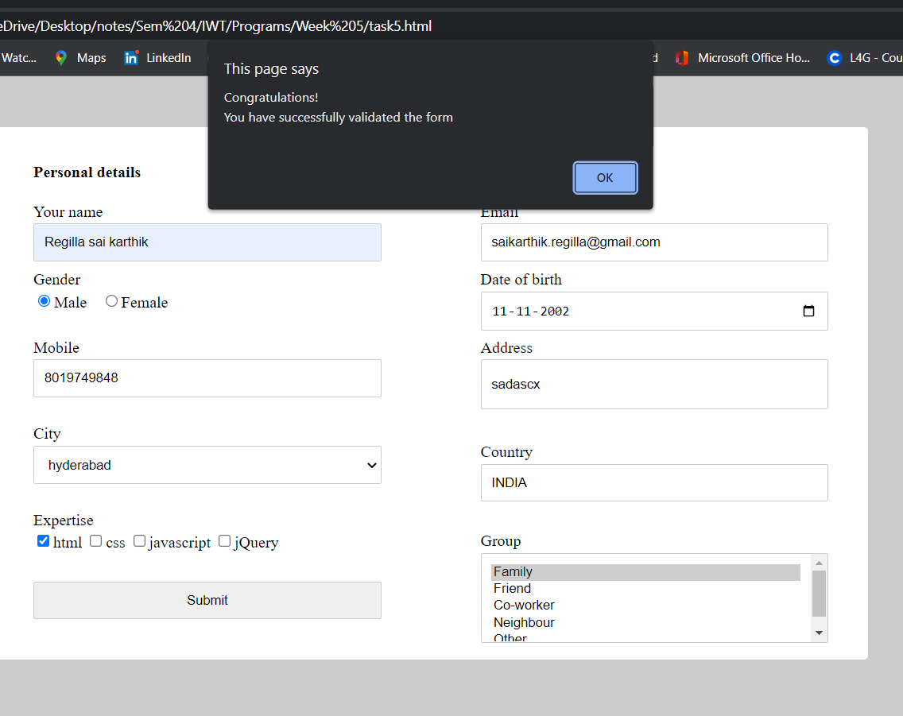

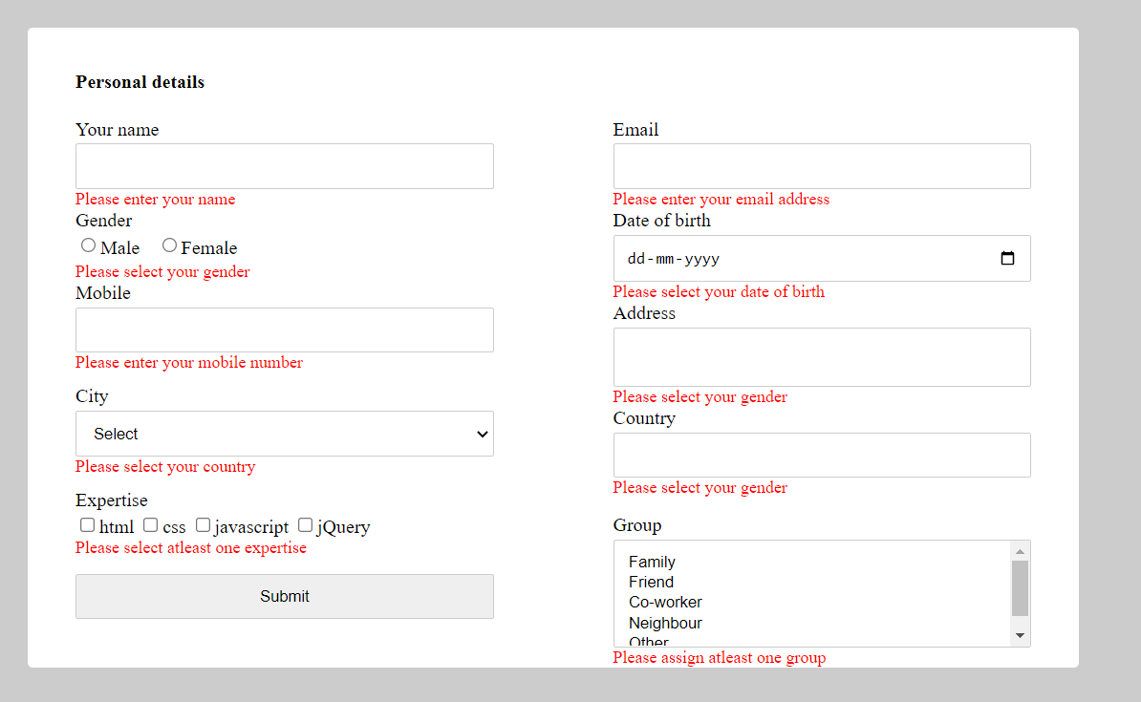

**CONCLUSION**

* The JavaScript code to validate the form fields runs successfully and validates all the fields in the form.